|  |
| --- |
|   John A. Walker College of Business**  **Appalachian State University** |

**CIS 3750 Sections 101, 102 & 103**

**Database Management**

**Exercise #2 – Multiple Table Query Intro**

## Query Exercise Detail

Use SQL and the tiny national community-based accommodation InstantStay database to run query on SSMS.

Make sure you use the database with your Last Name-First Name Initial.

It focuses on gathering the house owners and tenants together as a trusted platform. Hosts join to the system with their houses to be rented out. Similarly, guests join to the system to rent available houses. In addition, channels such as travel agencies, newspapers join InstantStay for connecting customers from different platforms.

In the OWNER table, data for the house owners are collected with their personal information as shown in the following table:

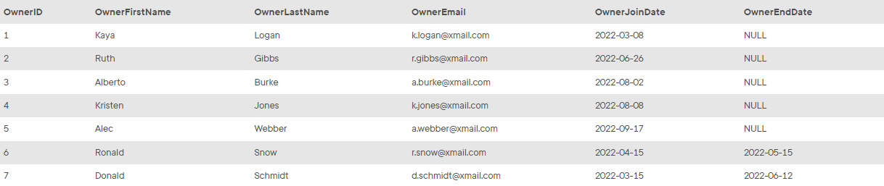

In the HOUSE table, all houses in InstantStay are collected with detailed address and respective characteristics about the houses:

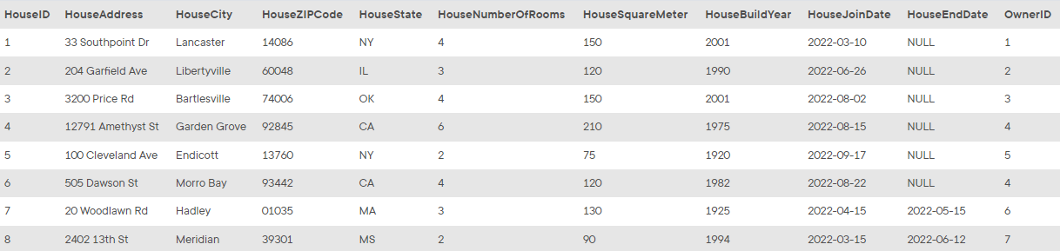

Guests are the customers registered to the platform to access information, offers and stay at houses in InstantStay. Data of the guests are collected in the GUEST table:

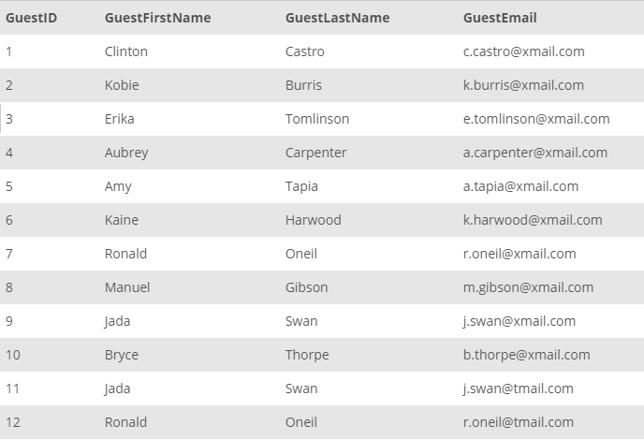

As a large platform, InstantStay hosts multiple channels with different commission rates. The channels related information is collected in the CHANNEL table:

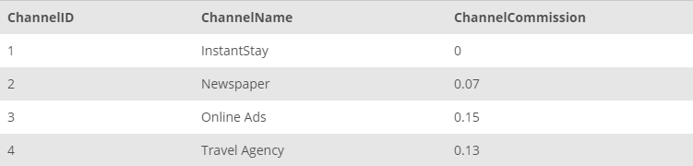

Finally, each reservation in the system is collected in STAY table. Reservations are collected with the corresponding house, guest and channel, start date, and end date. The price information with discount are also tracked in this table. Negative prices indicate the cancellations and the required repayments. Collected data for reservations are as follows:

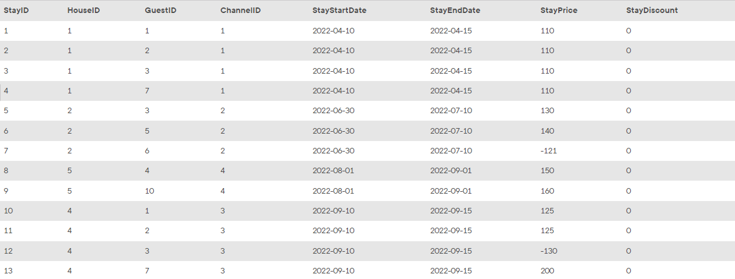

You are assigned as the database administrator to collect and manage transactional data of the InstantStay operations. Your main task is to create SQL scripts to help other teams in InstantStay to retrieve the required data. In the following tasks, you will collect the requested data to help other teams be successful on their business operations.

Make sure you put SQL syntax code below each task inquiry:

**1/ The InstantStay Legal team requires all house owner's first and last names along with their house ids and addresses. Collect the information from HOUSE and OWNER tables and return in a consolidated way.**

SELECT OWNER.OwnerFirstName,

OWNER.OwnerLastName,

HOUSE.HouseID,

HOUSE.HouseAddress

FROM OWNER JOIN HOUSE ON OWNER.OwnerID = HOUSE.OwnerID;

**2/ The InstantStay Finance team wants to collect all Stay IDs with the price, discount and channel commission rate.**

SELECT STAYID, STAYPRICE, STAYDISCOUNT, CHANNELCOMMISSION

FROM STAY JOIN CHANNEL ON STAY.ChannelID = CHANNEL.ChannelID;

**3/ During the guest user analysis, developers realized there could be duplicate users in the system. Check for the guests with the same name but different GuestIDs to check whether they are duplicate or not.**

SELECT *

FROM GUEST G JOIN GUEST H ON G.GuestFirstName = H.GuestFirstName

AND G.GuestLastName = H.GuestLastName

AND G.GuestID != H.GuestID;

**4/ List the first and last names of all owners who own a house’ number of rooms of two (2) or more? Use the IN operator in your query.**

SELECT OwnerFirstName, OwnerLastName

FROM OWNER

WHERE OwnerID IN (SELECT OwnerID FROM HOUSE WHERE HouseNumberofRooms >= 2);

**5/ In a case wherein guests are canceling the reservations or altering their stay days, the respective reimbursements and cancellations payments are reflected with negative prices in the reservation tables. The InstantStay Finance team requires the list of Stay IDs, GuestIDs, and the positive dollar amount rounded up to the nearest whole number.**

SELECT STAYID, GUESTID, CEILING(ABS(STAYPRICE)) AS REFUND

FROM STAY

WHERE STAYPRICE < 0;

SELECT STAYID, GUESTID, STAYPRICE

FROM STAY

WHERE STAYPRICE < 0;

**6/ List the address, StayStartDate, StayEndDate, and ChannelID with ChannelCommission is larger than or equal to 0.07? [1 bonus point – try yourself 2nd approach]**

SELECT House.HouseAddress,

Stay.StayStartDate,

Stay.StayEndDate,

Channel.ChannelID,

Channel.ChannelCommission

FROM HOUSE JOIN STAY ON HOUSE.HouseID = STAY.HouseID

JOIN CHANNEL ON STAY.ChannelID = CHANNEL.ChannelID

WHERE CHANNEL.ChannelCommission >= ANY

(SELECT CHANNEL.ChannelCommission FROM CHANNEL WHERE ChannelCommission >= 0.07);

--Second approach

SELECT House.HouseAddress,

Stay.StayStartDate,

Stay.StayEndDate,

Channel.ChannelID,

Channel.ChannelCommission

FROM HOUSE JOIN STAY ON HOUSE.HouseID = STAY.HouseID

JOIN CHANNEL ON STAY.ChannelID = CHANNEL.ChannelID

WHERE CHANNEL.ChannelCommission >= 0.07;

***What to turn in***

After you complete this assignment, please use the Word doc included in this assignment, put SQL syntax code answer for each task and turn in:

1. A SQL script file (.sql) containing all the necessary SQL commands solving required tasks
2. A properly prepared & named Word Doc (*.docx).

Rename the Word doc as your **LastName-FirstNameinitial.docx**

Make sure you name your file as “**LastName_FirstNaminitial –SSMS Exercise #2**” and upload on AsUlearn to earn ***20 points.***